SECOND HAND BOOK STORE

By
Diptesh Choudhury
Registration No. 135/19


5 year Integrated MCA
PG Department of Computer Science & Applications Utkal University
2022

PROJECT REPORT

ON
SECOND HAND BOOK STORE

SUBMITTED IN PARTIAL FULFILLMENT FOR AWARD OF DEGREE
IN
Integrated MCA
(BATCH 2019-2024)

BY

Diptesh Choudhury
Regd No 135/19

UNDER THE ESTEEMED GUIDENCE OF

Mrs Stitipragyan Mohanty



5 Year Integrated MCA
PG Department of Computer Science & Applications Utkal University
2022
Declaration

I hereby declare that the Project entitled “SECOND HAND BOOK STORE” submitted to the PG Department of Computer Science and Applications, Utkal University, Bhubaneswar, Odisha in partial fulfillment for the award of the degree of Integrated MCA in session 2019-2024 is an authentic record of my own work carried out under the guidance of Mrs. “Mrs Stitipragyan Mohanty” and that the Project has not previously formed the basis for the award of any other degree. The report has been prepared in compliance to the guidelines specified by the University.

Place: Bhubaneswar Date:

Diptesh Choudhury
[Regd.No-135/19]

This is to certify that the above statement made by these candidates is correct to the best of my knowledge.

Mrs Stitipragyan Mohanty
[Project Guide, IMCA]
Acknowledgement

I am very grateful to our project guide Mrs Stitipragyan Mohanty forgiving her valuable time and constructive guidance in preparing the Synopsis/Project. It would not have been possible to complete this project in short period of time without her kind encouragement
And valuable guidance.

Mr Diptesh Choudhury

Certificate
iii

This is to certify that the project entitled “Second Hand Book Store” submitted in partial fulfillment of the degree in Integrated MCA to the PG Department of Computer Science and Applications, Utkal University, Bhubaneswar, Odisha, done by Mr. Diptesh Choudhury, Registration No.135/19 is an authentic work carried out by her under our guidance and is worthy of acceptance for award of the degree. The work fulfils the entire requirement as per the regulation of the University and in our opinion, it has reached the standard needed for submission.

Mrs Stitipragyan Mohanty
[Project Guide, IMCA] [External Examiner]

Course Coordinator
5 years Integrated MCA, PG Dept of Computer Science and Application
Utkal University

Abstract

Second Hand Book shopping has been a current trend in recent age. The process of selling and buying the second-hand book is somehow lead to time and energy wastage. The purpose of this paper is to give solution through Online Second-Hand Bookshop System. The customer segment includes buyer, seller, and donator. This project has proposed conceptual solutions through Business Model Canvas (BMC), Value Proposition Canvas (VPC), and Environment Map(EM).

List Of Figures

Figure 1: | ER Diagram.
Figure 2: | Dataflow Diagram.
Figure 3: | Use case Diagram.
Figure 4: | Design Steps/Criteria.
Figure 5: | Levels of Testing.
Figure 6: | User Registration Page.
Figure 7: | Home Page.
Figure 8: | Registration Page.
Figure 9: | Login Page.
Figure 10: | Category Page.
Figure 11: | Products Page
Figure 12: Admin Page.
Figure 13: Log Out Page

Table of Contents

S.N | Content | Page No
 | Cover page as per format | i
 | Declaration of the Student | ii
 | Acknowledgement Certificate of the Guide/ center Manager- F4 | iii
 | Company Certificate | iv
 | Certificate | V
 | Contribution of Individual Team Members | Vi
 | Company Profile | Vii
 | Abstract | Viii
 | List of Figures | IX
 | List of Tables (optional) | X
1. | INTRODUCTION | 1
 | 1.1 Problem Definition and Objective(s)  1.2 Motivations(s)  1.3 Project Overview / Specifications  1.4 Hardware Specification  1.5 Software Specification  1.6 Organization of the Report | 1  1  1  2  2  5
2. | LITERATURE SURVEY | 2
 | 2.1 Existing System  2.2 Proposed System  2.3 Feasibility Study | 2  2  3
3. | SYSTEM ANALYSIS & DESIGN | 4
 | 3.Requirement Specification  3.1.1 Functional Requirements  3.1.2 Non-functional Requirements  3.2 ER Diagrams/UML Diagram / Data Flow Diagram  3.3 Design Steps / Criteria  3.4 Algorithms and Pseudo Code | 5  5  6  8  13  14
4. | TESTING PROCESS  4.1 Unit Testing  4.2 Integration Testing | 14  14  14
5. | RESULTS AND DISCUSSIONS  5.1 User Interface  5.2 Databases  5.3 Results and Outputs | 15  15  15  15
6. | CONCLUSION AND FUTURE SCOPE  6.1 Conclusion  6.2 Future Scope | 25  25  25
 | REFERENCES | 26

INTRODUCTION

It is an online website where customer can buy second hand books. Through web browser customer can search for the book later add to the cart and finally purchase it. The books are divided into categories to make the search easier. The user give feedback about the books.

Problem definition

To make the buying and selling of second-hand books easier for school and college students. A used book or secondhand book is a book which has been owned before by an owner other than the publisher or retailer, usually by an individual or library.

Objective

The main objective is to provide a second-hand book at convenient price. To save the time of users to provide books online. To provide service to distant areas. User can buy used book according to their need.

Motivations

Used books may cost you only half the rate of new books. By buying then you may cut costs and buy more books with that money you have saved. The second-hand book shop is a box of surprises. You never know which book you may bump into next.

Project Overview & Specifications

The purpose of this project is to create a communication and user- friendly web portal for selling and buying secondhand books online.

Shopping cart that is visible at all times and maintains its state delete update from shopping cart. A checkout process that is smooth. A page to show the items shopped made by the user showing shipping and location details. Payment service that people can trust to leave their credit card numbers. You do not have to member to buy books. Hence anonymous user can buy books.
.

I.Hardware Specification

Processor: Quad core and above

RAM: 1GB or above

Minimum storage: 512 mb and above

II.Software Specification
Operating system: Windows, Linux, Mac OS

Tool: Visual studio Code

Database: MySQL

Front-end: HTML, CSS, JS, Bootstrap

Back-end: MySQL
Browser Requirements: Only a web browser. For e.g. Google Chrome,
Mozilla firefox, Safari, Opera Mini etc.

2.LITERATURE SURVEY

2.1 Existing System

Things going manually like going to books of and checking the books and buying the books. No security for database because all books information is kept in
records and that work is also done by man by using
manpower. So, there is chance of doing mistake.

2.2 Proposed System

In this project you can view any book very easily online. You can purchase online books by selecting any payment gateway. This is controlled by a admin who have full control over all the books. All the books are stored into the database. So, there is fill security of theft of payment etc. Online bookstore provides a platform where all the books are kept in an arranged way and you can choose your required book by just selecting it from the store. After selecting books and view all the descriptions such as name of books, name of author and price, user can make payment of it in order to get it.

2.3 Feasibility Study
The problem is analyzed, and feasibility study is also performed for making sure that it is feasible for creating such a web site. The feasibility report is created and mainly 3 types of feasible studies are performed.
      - Technical Feasibility
      - Functional Feasibility
      - Time Feasibility

Technical Feasibility

Technical Feasibility centers on the existing computer and to what extend it can support the proposed addition. In technical feasibility both software and hardware feasibilities are checked. In the case of hardware, the created software can be executed on any configurations in which Microsoft windows operation system works.

Functional Feasibility

All functional and non-functional requirements have been analysed. Functional requirements are the one the minimum things the system should support. Non-functional requirements are mainly to avoid external events that can affect the system performance. The proposed system is beneficial only if they can be turned into information system that will meet the organization’s functional requirements.

Time Feasibility

Will the proposed project be completed within the stipulated time frame effectively? As the analysis shows, the project has a scope for a long period of time. The stipulated time for, the project is 3 months, and it can be completed within that span of time.
As this project is technically, functionally, timely feasible, the system is judged feasible. Viewing the collected information, recommendation and justification, conclusions is made of the proposed system.

3.SYSTEM ANALYSIS & DESIGN

3.1Requirement Specification
3.1.1 Functional Requirements
A functional requirement defines a system or its component.
It specifies “What should the software system do?”.
Functional requirement is specified by User.

1. Registration Module
2. Login Module
3. Book Management Module
4. Order Module
5. Admin Module

1.Registration Module
User need to register first with their basic registration details and need
to create a valid id and password.

2.Login Module
Using valid login credential, user need to login into the system in order to
access the system.

3.Book Management Module
I. View Books:
Once user is logged into the, he/ she may view all the added books with their
Details
II.Buy Books:
User can surf various book of their choice and buy them.
III.Add Books:
System allows user to sell their books online buy added the book name and
its details.
IV.Upload Books:
User need to upload a book, if he/she wants to sell a book.

4.Order Module

- My Orders:
All the purchase history of user
will be displayed with details.

- View Buyer:
If any buyer is interested in buying
a book or any one buys a book from
the user then buyers’ details will be
displayed.
5.Admin Module

- Login:
Using valid login credentials, admin need to login into the system in order
to access the system.
- View Books:
Admin can view all the added books online with their details.
- View transaction:
System allows admin to view all the transaction details of buying and selling
a book.
- d. View User:
- All the registered user details will be displayed to the admin.

Non-Functional Requirements
A non-functional requirement defines the quality attribute of a software system
It places constraints on “How should the software system fulfil the functional requirements.
(a)Reliability
(b)performance
(c)Security
(d)Usability
(e)Safety
(f)Supportability

(a) Reliability

The system should be available when requested for service by users. The system should have a very low failure rate.

(b) Performance

The system must have a good response time. The system must run error free

while operating with a huge set of data.

(c) Security

All external communications between the system’s data server and clients must be encrypted.
The access permissions for system data may only be changed by the system’s data administrator.

(d) Usability

The system should include well-structured user manuals. The system should have Informative error messages. Efficient help facilities. The system should have a well-formed graphical user interface. The system should be user friendly.

(e) Safety

The system should maintain a good back up.

(f) Supportability

The system should be able to be transferred from one environment to another. The system should be easy to maintain. The system should be able to be used on multiple platforms.

3.2 ER diagrams/ UML /Data Flow Diagrams

3.2.1 ER Diagram

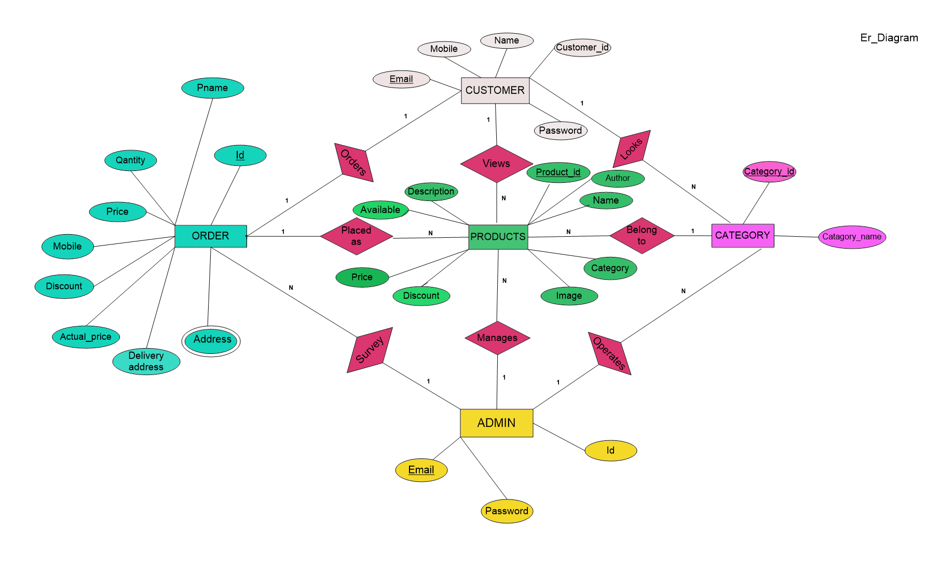

3.2.2 Dataflow Diagram

3.2.2.1Level-0

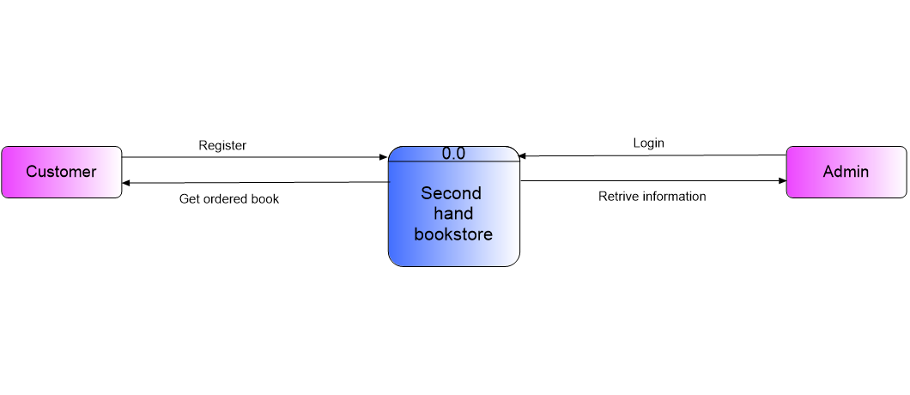

Level-1 (DFD for Admin)

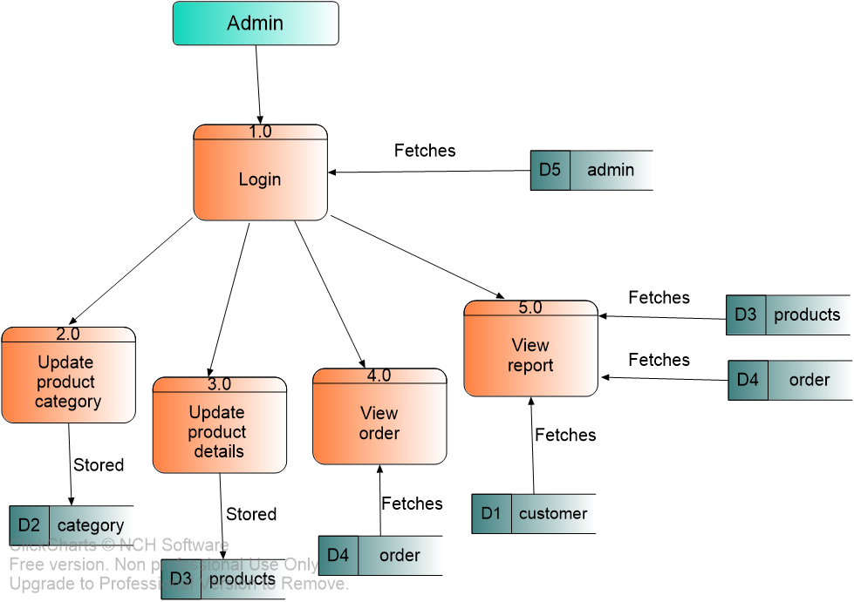

Level-1 (DFD for Customer)

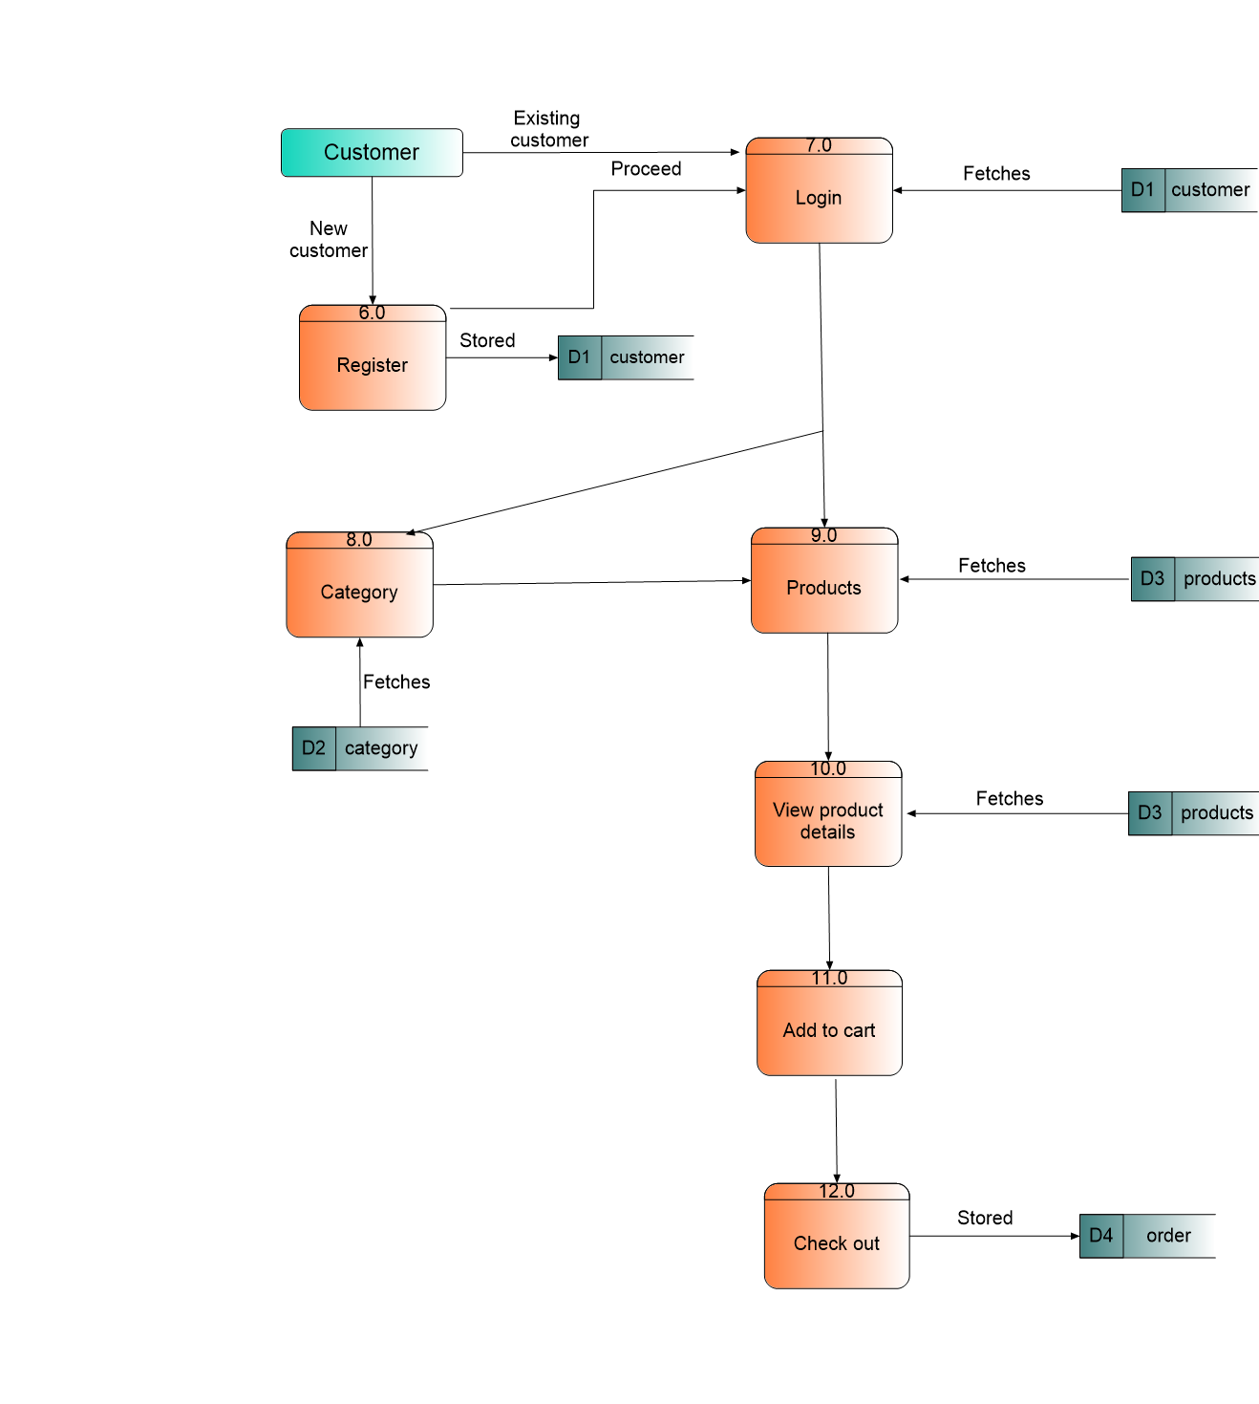

Use Case Diagram

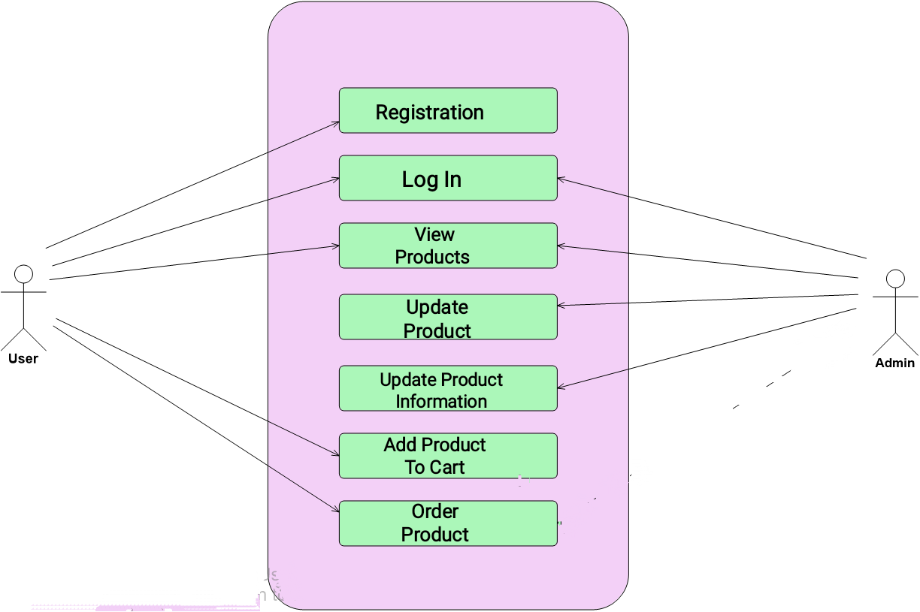

3.3Design Steps

Systems design is the process of defining elements of a system like modules, architecture, components and their interfaces and data for a system based on the specified requirements. It is the process of defining, developing, and designing systems which satisfies the specific needs and requirements of a business or organization.

4.TESTING PROCESS

Testing is a process, to evaluate the functionality of a software application with an intent to find whether the developed software met the specified requirements or not and to identify the defects to ensure that the product is defect-free to produce a quality product.

Types of Testing

a. Manual Testing: Manual testing is a process of testing the software by hand to learn
more about it, to find what is and is not working.

b. Automation Testing: Automation testing is the process of testing the software using
an automation tool to find the defects.

Testing Methods

(a)Static Testing
It is also known as Verification in Software Testing.
Verification is a static method of checking documents and files. Verification is the process, to ensure that whether we are building the product right i.e., to verify the requirements which we have and to verify whether we are developing the product accordingly or not.
(b) Dynamic Testing:
It is also known as Validation in Software Testing. Validation is a dynamic
process of testing the real product. Validation is the process, whether we
are building the right product i.e., to validate the product which we have
developed is right or not.

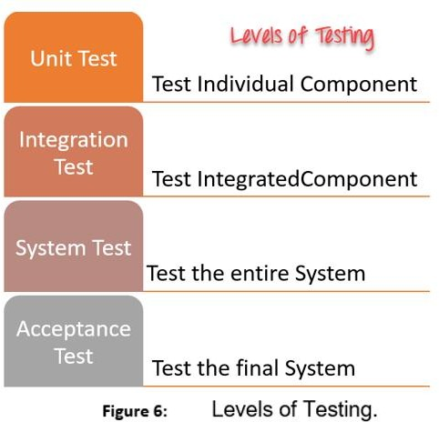
Testing Levels

- Unit Testing

This software testing basic approach is followed by the programmer to test the unit of the program. It helps developers to know whether the individual unit of the code is working properly or not.

- Integration Testing
It focuses on the construction and design of the software. You need to see that the integrated units are working without errors or not.

(c) System Testing (End to End Testing) Testing:

In this method, your software is compiled as a whole and then tested as a whole. This testing strategy checks the functionality, security, portability, amongst others.

(d)Acceptance

It is a kind of testing conducted to ensure whether the requirement of the users is fulfilled prior to its delivery and the software works correctly in the user’s working environment.

5. RESULT AND DISCUSSIONS

5.1User Interface

User of the system will be provided with the graphical user interface,

there is no command line interface for any functions of the product.

5.2 Databases

The database is used for the purpose of handling information as an integrated

whole. It is defined as a collection of interrelated data stored with less or no

redundancy to serve many users quickly and effectively. We should design a

database to see how data should be organized around user requirements.

The objectives of the database is to make information access, easy quick,

Inexpensive and flexible for other users. During database design the following

Objectives are concerned:

Data independence

Accurate and integrating

More information at low cost

Recovery from failure

Privacy and security

Performances

5.3 Results and Output

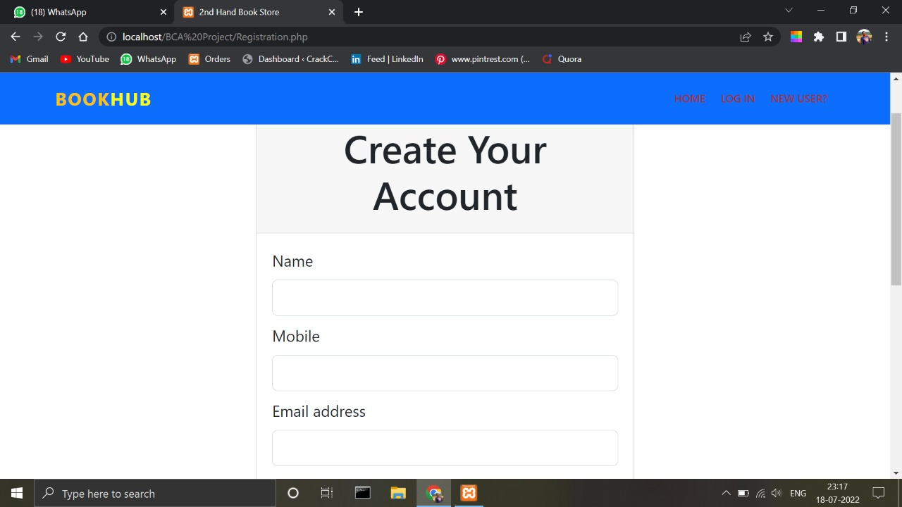





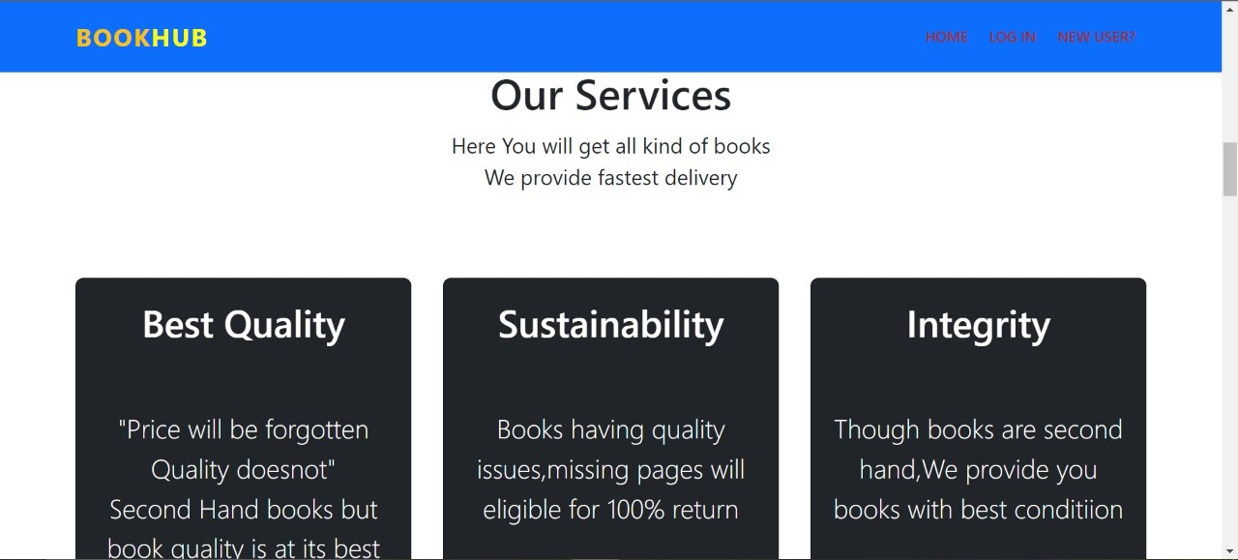

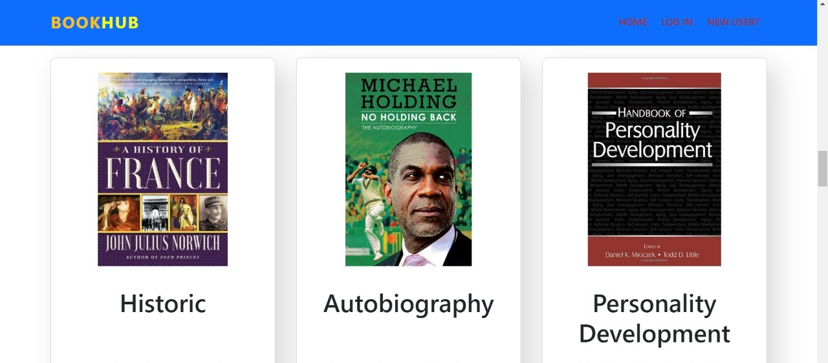

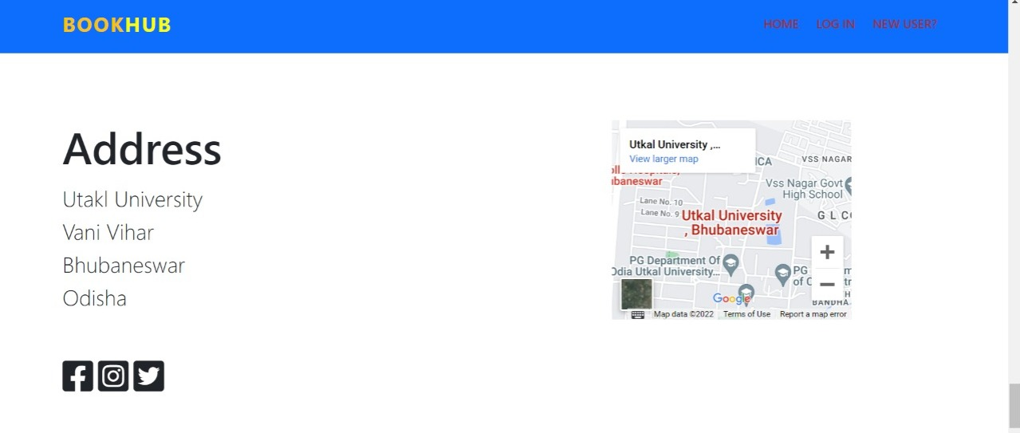

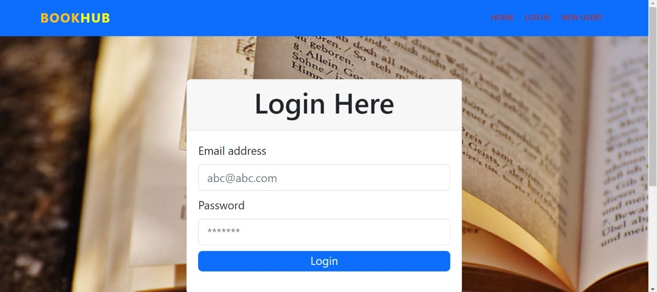

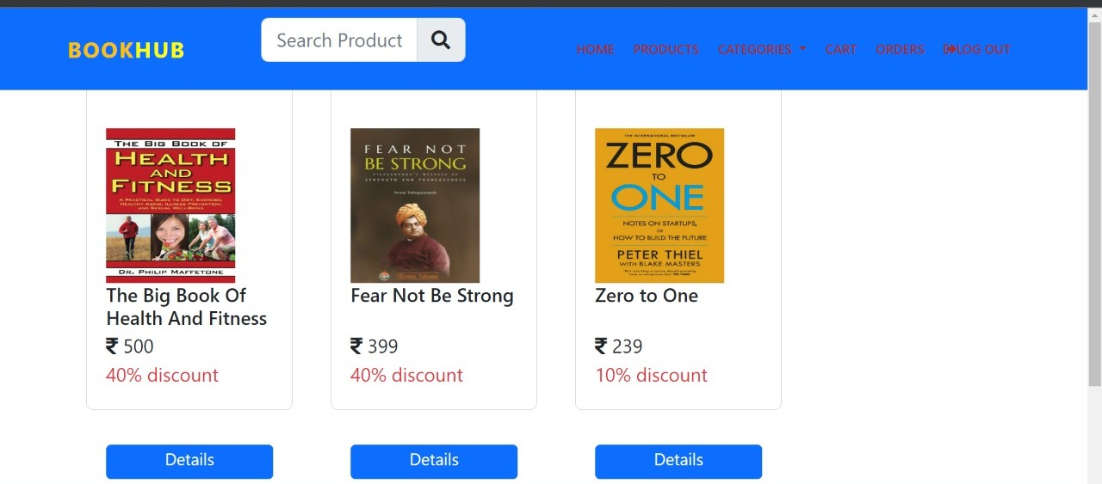



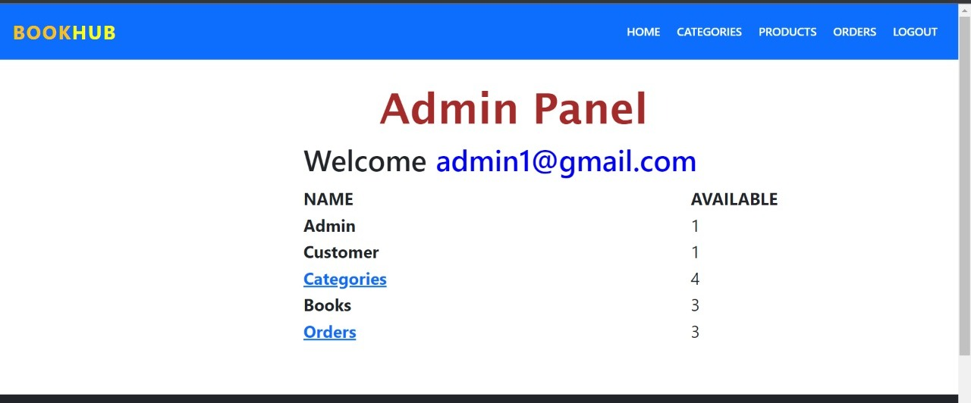
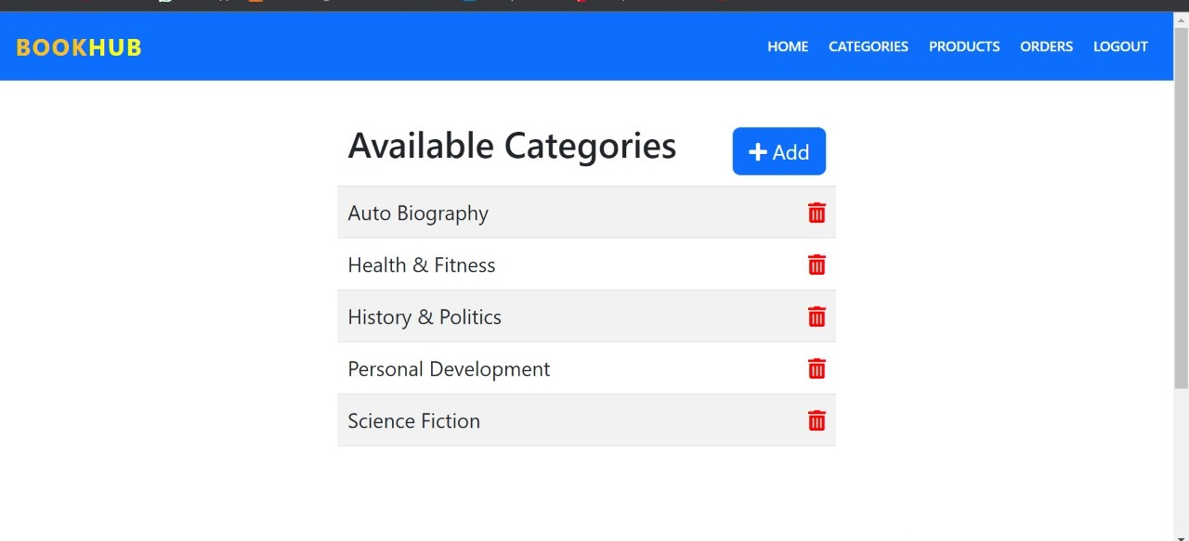

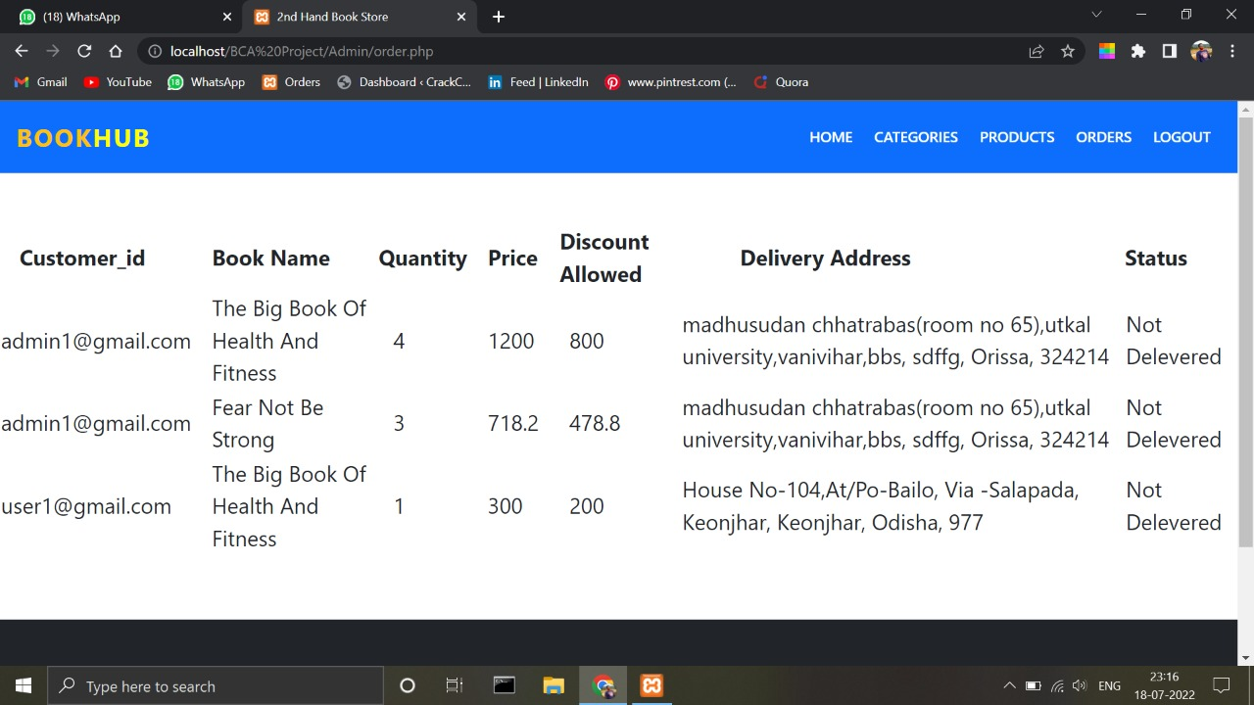
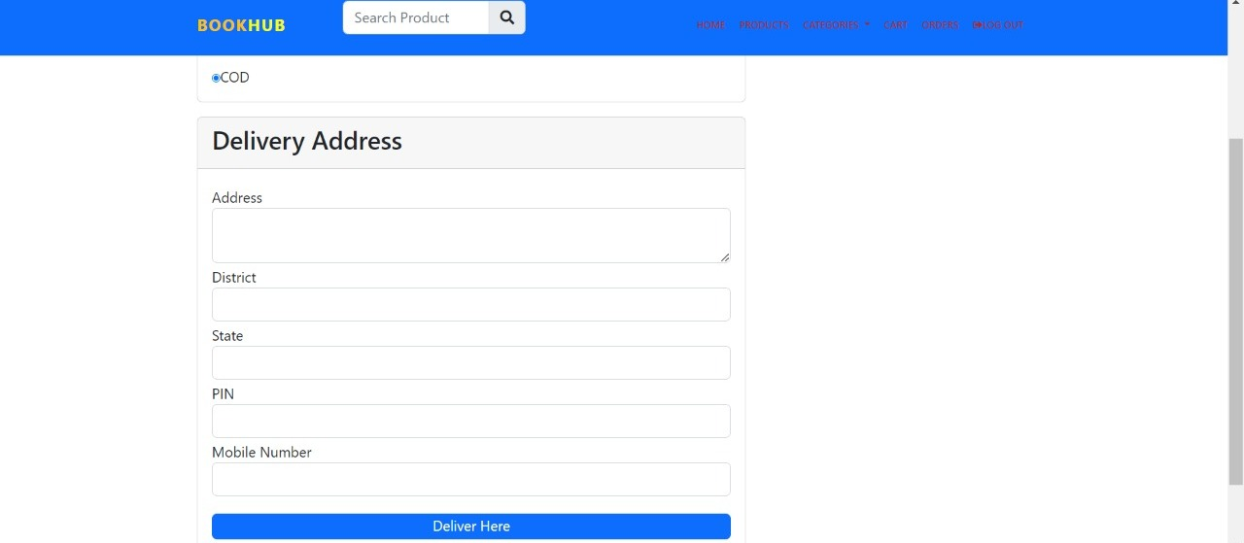

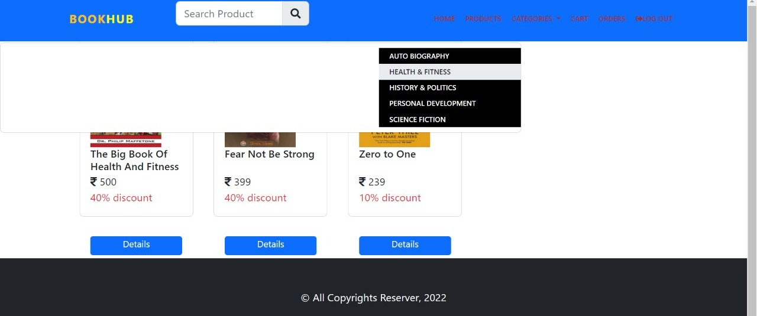

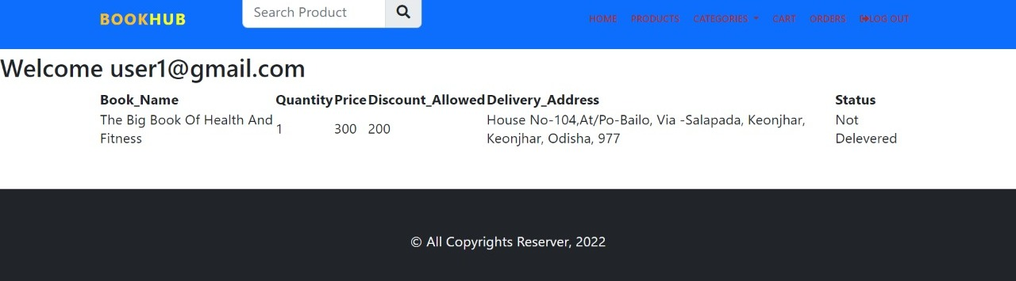

.

6.CONCLUSION AND FUTURE SCOPE

6.1 CONCLUSION:

Hence, we have developed an web site which will help
user to exchange, buy and sell their books. User can also interact with each
other on this platform. There is no time barriers in selling the products. One
can log on the internet even at midnight and can sell products at a single
click of mouse. An interactive user friendly and focused website in the form
of online shop can generate good business so, we are of the opinion that big
companies should invest more on research and development for second
hand books.

6.2 FUTURE SCOPE:
Customer can check delivery availability.More payment systems can be added such as UPI and Car.Feedback section will be added. Customer can sale their books on our website also.Security will be increased.

REFERENCES:

- BOOKS: - books.google.co.in/?hl=en&tab=rp&authuser=0

- HTML: - https://www.youtube.com

- CSS: -
https://css-tricks.com/almanac/
- BOOTSTRAP: -
https://getbootstrap.com/docs/5.0/getting-started
- PHP: -
https://W3schools.com
- MySQL: -
https://W3shools.com

THANK YOU

